Chapter 15 Homework Problems

Problem 15.1

A flywheel with a diameter of 2 ft and a weight of 60 lbs is rotating at a rate of 600 rpm. A brake applies a friction force to the outer rim of the flywheel, bringing it to a stop is 1.5 seconds. Based on this information, what was the average friction force applied by the brake over this time?

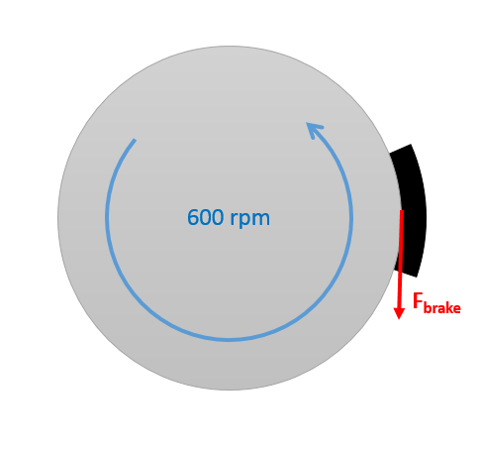

(Solution: $F_{brake}=39.01 lbs$)

Problem 15.2

A ring-shaped space station can be approximated as a thin ring 60 meters in diameter with a mass of 500,000 kg. Centrifugal acceleration of the spinning station will be used to simulate gravity.

1. To simulate the 9.81 m/s2 of earth, how fast will the station need to be spinning.
2. If two thrusters each capable of exerting 10 kN of force will be used to get the station up to this speed, how long will we need to run the thrusters?

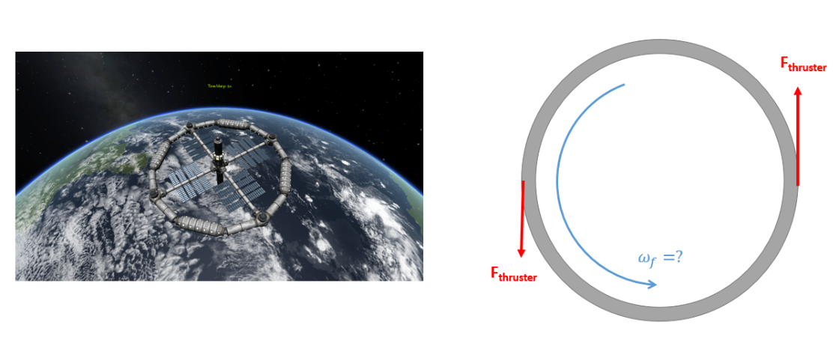

(Solution: $ω_{f}=.571\frac{rad}{s}, t_{thrust}=428.25 s$)

Problem 15.3

A 50-kilogram barrel as shown below falls off a truck traveling 35 m/s and lands on the road (assume no bouncing). The barrel has no initial angular velocity, but the barrel begins to roll as it slides along the road. The kinetic coefficient of friction between the road and the barrel is .3.

1. How long will it take before the barrel rolls without slipping?
2. What is the final linear and angular velocity for the barrel?

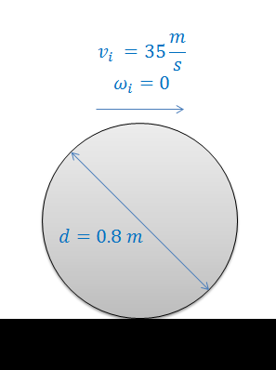

(Solution: $t=3.96 s, v_{f}=23.33\frac{m}{s} ω_{f}=-58.33\frac{rad}{s}$)

Problem 15.4

A satellite consists of a central cylindrical body (radius 1 meter, mass 200 kg) and two solar panels (mass 50 kg each) with the initial dimensions shown below. The satellite is rotating at an initial rate of 0.5 rad/s when it folds both of its solar panels into the upright configuration. Assuming there are no outside forces on the satellite, what is the expected angular velocity after folding up the solar panels?

(Solution: $ω_{f}=2.22\frac{rad}{s}$)

Problem 15.5

A slender rod with a length of 40 cm and a mass of 2 kg is falling at a rate of 1.5 m/s and at a 35-degree angle as shown below. The rod then strikes a surface and rebounds off it. Assuming that the coefficient of restitution for the impact is .9, and that there is negligible friction between the body and the surface, what is the expected velocity of the center of the rod (C) and the angular velocity immediately after impact? (Hint: The equations will give you a set of mathematically valid answers, in the actual solution the center of the rod will still be traveling downwards after the impact)

(Solution: clockwise)